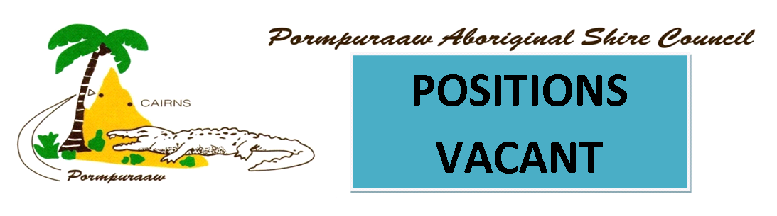SENIOR PLUMBER
1 x Full Time Position (Must be available to work Monday- Friday and reasonable overtime.)

Applications close 20 July 2021
Reporting to the Executive Manager of Operations with two (2) direct reports, the Senior Plumber is responsible for providing sound and reliable technical support to PASC for the:
- Water Reticulation Infrastructure
- Waste Water Infrastructure
- Splash park
- Community Housing
- All other council buildings and assets in relation to plumbing and gas.
This is an ‘essential services’ position and will be required to be on-call to deal with any emergencies if/when they arise. The position is responsible for the provision and maintenance of accurate records of compliance, routine maintenance and inspections of infrastructure and assets; and includes all compliance inspections to ensure conformity with relevant legislation and investigations of any alleged contraventions of legislation. Strong communication and interpersonal skills with strong leadership and the ability to train and mentor staff are also essential to the role
- Additional key responsibilities include, but are not limited to:
- Provision of sound and reliable technical support to Council
- Undertake compliance inspections of sanitary plumbing and drainage installations to ensure conformity with relevant legislation, best practice and related approvals/permits
- Maintain accurate records of compliance inspections.
- Conduct investigations into and where necessary resolve alleged contraventions of statutory legislation and other matters relating to sanitary plumbing and drainage.
- Contribute to the preparation of documentation, correspondence, reports and notes relevant to plumbing matters for control and guidance of environmental aspects in the community.
- Contribute to the preparation of documentation, correspondence, reports and notes relevant to plumbing matters for control and guidance of environmental aspects in the community.
- Assess site and soil evaluation reports to ensure compliance with Council policy and relevant legislation.
- Oversee operation and daily maintenance of water reticulation infrastructure including the Water Splash Park as follows:
  - Conduct water testing and prepare reports.
  - Conduct all reporting requirements for water infrastructure as required
- Oversee operation and daily maintenance of waste water infrastructure
- Conduct any routine or plumbing maintenance and repairs as required by Council.
- Train and mentor staff.

Qualifications  In order to be able to do this role you must hold:  - Plumbing & Drainage licence  - Gas Work Licence  - Commission and Maintain Back Flow Devices Endorsement  - Evaluating and Planning the Installation of Solar & Heat Pump Water Systems  - Certificate II or III Water Operations  - Certificate II or III Waste Water Operations  - A construction white card or interstate equivalent  - Blue Card  - National Criminal History Clearance  - A current “C” Class Driver’s Licence must be maintained at all times. | Selection Criteria  To be successful in this role you must have:  - Demonstrated extensive background working in plumbing and with legislative requirements  - Demonstrated ability to provide sound and reliable technical advice to council  - Demonstrated ability to oversee the daily operations and maintenance of the water reticulation infrastructure and waste water infrastructure.  - Demonstrated experience in undertaking compliance inspections of sanitary plumbing and drainage installations  - Thorough knowledge of relevant national plumbing and drainage codes  - Expertise in the interpretation of reports, assessments and proposed treatments  - Demonstrated ability to conduct investigations into and where necessary to resolve alleged contraventions of statutory legislation
To apply for a position:
- Contact Human Resources for a copy of the Position Description and;
- Submit your cover letter, selection criteria response & resume to HR on email: hr@pormpuraaw.qld.gov.au

