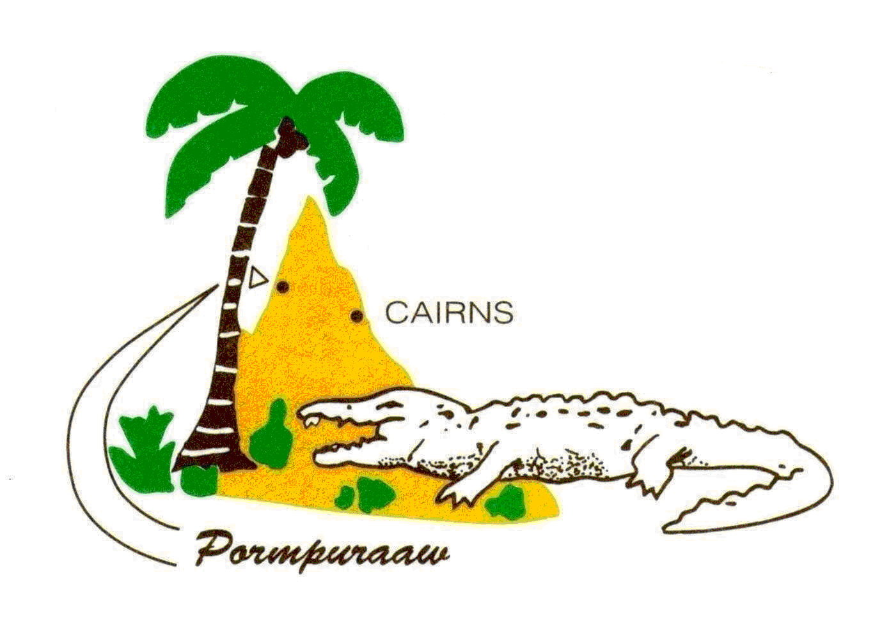
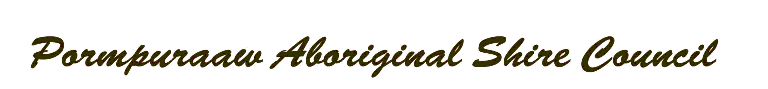

C/- Post Office
PORMPURAAW QLD 4871

Ph: (07) 4060 4601
Fax: (07) 4060 4654
Mobile: 0408 155 019
Email: ceo@pormpuraaw.qld.gov.au

Minutes (Draft) Council Meeting
Date: Wed, 29 July 2020 at 10.00am.

- Present: Mayor Richard Tarpencha, D/Mayor George Conrad, Cr Tim Koo-Aga, Cr Ronald Kingi, Cr Andrea Foote, CEO Edward Natera (Minute Secretary).
- Apologies: Nil.
- Declaration of any Conflict, any perceived or other Potential Conflict of Interest to be declared prior to meeting by Councillors ( Sect 173 of LGovt Act 2009 ): Nil.
- Related Party Declaration Form (RPDF), (Sect 171B of LGovt Act 2009): Confirmation of any changes to RPDF by Councillors & Senior Managers: Nil.
- Matters arising from the Minutes: That Council confirm the Minutes of the meeting dated Wed, 24 June 2020 as true & correct. Moved: Cr Koo-Aga. Seconded: Cr Conrad. CARRIED. Resolution: 2020/07/01.
- Delegations/Guests:
- Correspondence: List of inwards correspondence tabled for information:
- Reports:
  - Mayor’s Report:

- 8.1.1: Budgets 2020-2021 (B2021): see Special Purpose Report (SPR) & full docu on B2021. Motion: That Council accepts B2021 as tabled by Mayor Tarpencha for adoption noting that: Total Revenue: M$15,308,744, Total Expenditure: M$10, 910,396, Depreciation Cost: M$5,381,372. QTC: investment is at 1.8%. Wages blanket application at 3.5%, employment is assumed at 100%.
Statement of estimated Financial Position and Operating Statement for period 2019-2020. Moved: Cr Koo-Aga. Seconded: Cr Conrad. CARRIED. Resolution: 2020/07/02.
- 8.1.2: Budgets 2020-2021, Schedule of Fees & Charges 2020-2021 ( SFC2021): see SPR & full docu on SFC 2021. Motion: That Council accepts the SFC2021 as tabled by Mayor Tarpencha for adoption. Moved: Cr Conrad. Seconded: Cr Kingi. CARRIED. Resolution: 2020/07/03.
- 8.1.3: Budgets 2020-2021, Policies: Revenue, Investment & Debt 2020-2021 (PRID2021 ): see SPR & full docu on PRID202, there are no changes to prior years. Motion: That Council accepts the PRID2021 as tabled by Mayor Tarpencha for adoption. Moved: Cr Kingi. Seconded: Cr Conrad. CARRIED. Resolution: 2020/07/04.
- 8.1.4: Docu received titled Special Project Officer (SPO): see docu re SPO tabled on Wed, 24 June by Mayor Richard without Notice. Motion: That Council accepts the SPO docu & more discussions on the requirements of the SPO, the Pros & Cons, Budgets and Due Process, noting that this will be a Work in Progress Proposal. Moved: Cr Conrad. Seconded: Cr Kingi. CARRIED. Resolution: 2020/07/05.
- 8.1.5: Docu received titled Matters of Concern (MOC): see docu re MOC received from Mayor Richard on 01 Jly. Mayor Richard to take the lead and open up discussions on this MOC. Motion: That Council accepts & discuss this MOC in the most professional manner noting that there is a Code of Conduct, Local Govt Act & Belcarra that every elected member are bound to abide by and that each member will now agree to move forward as a collective group after frank & honest discussions are made on MOC. Moved: Cr Conrad. Seconded: Mayor Tarpencha. CARRIED. Resolution: 2020/07/06.

  - CEO’s Report:
- 8.2.1: Attendance Certificate (AC): see AC dated 29 July 2020 and approved for payment at $1,473.60 each for Cr Foote, Cr Kingi & Cr Koo-Aga.
- 8.2.2: Audit, Independent Audit Committee (IAC): see SPR docu dated 02 Jly on IAC. Motion: That Council confirms receipt, acceptance and adoption of IAC Audit Charter and Audit Policy as tabled. Moved: Cr Kingi. Seconded: Mayor Tarpencha. CARRIED. Resolution: 2020/07/07.
- 8.2.3: Audit, Audit Interim Report (AIR): see SPR docu dated 07 Jly on AIR from Qld Audit Office. Motion: That Council confirms receipt, acceptance and adoption of AIR. Moved: Cr Kingi. Seconded: Cr Koo-Aga. CARRIED. Resolution: 2020/07/08.
- 8.2.4: Crime & Corruption Commission (CCC): see SPR & full docu on CCC & the issue with former Mayor Chris Loft from Fraser Coast Regional Council. Motion: That Council confirms receipt, acceptance and understanding of this SPR & CCC Prevention in Focus which is part of capacity building of Council. Moved: Cr Kingi. Seconded: Cr Conrad. CARRIED. Resolution: 2020/07/09.
- 8.2.5: Position Paper on Covid 19 Commercial Rental Relief (PPCCRR): see docu on PPCCRR on Commercial Rent Relief. Motion: That Council confirms receipt of PPCCRR and well not evict any Commercial Renters, will negotiate terms and will not reduce/waive any Rental amounts. Moved: Cr Foote. Seconded: Cr Conrad. CARRIED. Resolution: 2020/07/10.
- 8.2.6: Pormpuraaw Local Disaster Management Plan (PLDMP): see revised docu on PLDMP & SPR for 2020-2021. As per Disaster Management act 2003 Sect 57 & 58 PLDMP was to be reviewed annually. Motion: That Council confirms receipt of PLDMP ans accepts for adoption as tabled. Moved: Cr Conrad. Seconded: Cr Kingi. CARRIED. Resolution: 2020/07/11.

  - Deputy CEO’s Report:
- 8.3.1: Governance ( DCEO ): Council notes that position is vacant and placement is WIP. Duties are shared between Corporate Services Mgr & CEO and have covered: Audits, By-Laws ( Undesirables ), Leases, Rents, Public Works Extinguishment. Motion: That Council notes oversights by CSM & CEO and accepts above arrangements. Moved: Cr Kingi. Seconded: Cr Conrad. CARRIED.
Resolution: 2020/07/12.

  - Corporate Services Executive Manager’s Report:
- 8.4.1: Corporate Service Executive Manager (CSEM): General Report dated 25 Jly 2020 received and covered: General Finance, Grant Acquittals & Reporting, Current Corporate Service Projects, HR, Admin Store, Guest House.
Motion: That Council accepts the CSEM report dated 25 Jly as tabled. Moved: Cr Koo-Aga. Seconded: Cr Conrad. CARRIED.
Resolution: 2020/07/13.
- 8.4.2: PASC Draft Index Report for Asset at 30 Jne 2020:(DIR): see docu on DIR work for comprehensive asset valuation for 2019-2020 and 2020-2021.
Motion: That Council accepts the DIR work that will ensure that PASC can control massive spikes in Asset Valuations. Moved: Cr Kingi. Seconded: Cr Foote. CARRIED.
Resolution: 2020/07/14.
- 8.4.3: Internal Audit Report Review of Desktop Index Valuation (IARRDIV): see docu on IARRDIV work for comprehensive asset valuation for 2019-2020 and 2020-2021.
Motion: That Council accepts the IARRDIV work that will ensure that PASC incorporates correct accounting treatment to mitigate potential Audit Qualifications. Moved: Cr Kingi. Seconded: Cr Foote. CARRIED.
Resolution: 2020/07/15.
- 8.4.4: Human Resource: (HR): HR report for June 2020 tabled covering: Month in Review, HR Training/Conference, Reporting,
Projects,
New Starters, Terminations/Resignations, Recruitment, Training, Breakdown of Wages. Motion: That Council accepts the HR report for June 2020. Moved: Cr Conrad. Seconded: Cr Kingi. CARRIED. Resolution: 2020/07/16.

  - Operations Executive Manager’s Report:
- 8.5.1: Operation Executive Manager Report (OEMR): OEMR received dated 17 July 2020 covering: Airport, RnM, Main Roads, Parks n Garden, Plumbing, Housing, Projects,
Workshop, Splash Park, Bakery, Library Upgrade, New Playground equipment.
Motion: That Council accepts the OEMR dated 17 Jly 2020 as presented for adoption. Moved: Cr Conrad. Seconded: Cr Kingi. CARRIED. Resolution: 2020/07/17.

  - Community Service Manager’s Report:
- 8.6.1: Community Service Executive Manager (CSEM): Council to note that this position is vacant (advt currently WIP). Duties are being spread across Corporate Ex Finance & CEO and has covered: Aged care: SDAP process, Centrelink: staff shortage, Justice Group: Integrated DV Officer & Coord interviews, Grant Funding, Qrt Activity Report,
Motion: That Council notes above arrangements and oversight. Moved: Cr Kingi. Seconded: Cr Conrad. CARRIED.
Resolution: 2020/07/18.

  - Environment Manager’s Report:
- 8.7.1: Environment Exec Mgr (EEM) Report: EEM Report received dated 16 June 2020 covering: Carbon Abatement/Hazard Reduction, Sea Turtle Nest Protection,
ICCIP
Weed Control
Training, Program Reporting,
Unauthorised Access.
Motion: That Council confirms & accepts the EEM Report dated 16 June 2020 as tabled. Moved: Cr Foote. Seconded: Cr Koo-Aga. CARRIED.
Resolution: 2020/07/19.

10. Tenders & Quotations: Nil.

11. Notice of Motion: Nil
12. Meeting Closed: 12.48pm.
13. Next Meeting: 26 Aug 2020.

Minutes accepted as true & correct.

……………………………….. ………………………………………….
Richard Tarpencha: Mayor. Edward A Natera. CEO. 26 Jly 2020.

